VOLUNTEER HOURS
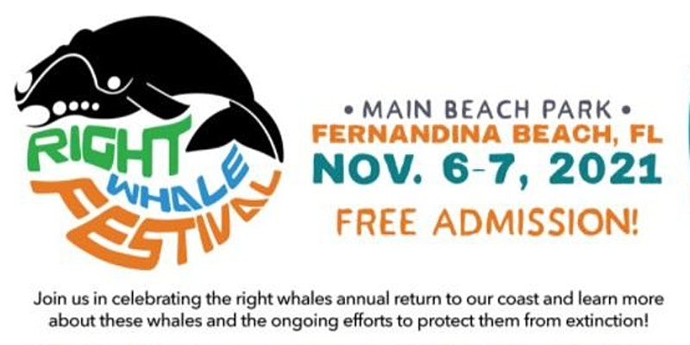

About this event
​Prior to the gate opening on the 2021 Right Whale Festival, Keep Nassau Beautiful (KNB) and community volunteers will remove litter and debris on the beach, beach access points, and beach parks and parking lots to ready the ocean nursery for the calving season.
KNB will provide supplies including: Grabbers while they last, disposable or reusable gloves, litter collection totes, and trash bags for disposal of collected litter. Volunteers are asked to sign a waiver, those under 16 the waiver should be signed by a parent or guardian.
Volunteers please bring your own grabber and gloves if preferred, shoes appropriate for the cleanup area, reusable water bottle, and sunscreen.
CDC Guidelines for safety which are in place at the time of cleanup will be followed.
To register for volunteering: https://keepnassaubeautiful.org/news-and-events/#volunteer
Become a Keep Nassau Beautiful volunteer during the Right Whale Festival — Help Keep Nassau Beautiful educate Festival participants on Reduce, Reuse, Recycle and the Do’s and Don’ts of recycling.
This is a family-friendly activity. Youth are encouraged to participate. Volunteering qualifies for Community Service hours. All Volunteers sign a waiver, under 16 the waiver must be signed by parent or guardian. Participants will be assigned a recycling containter to protect from non-recyclables during the festival.
Keep Nassau Beautiful will provide training and a KNB representative will be available during the festival to answer any questions and sign community service forms.
Shifts are available or you may volunteer for the entire day, 10am – 6pm. Contact KNB 904-261-0165 or knb@keepnassaubeautiful.org
Register at Keep Nassau Beautiful's website.

